CSSE 230 Logger Setup Steps

Project properties setup
  - Go to properties, and add these to the build path
  - Add libraries
    - JUnit 5 should be under Classpath
  - Add JAR dependencies: Logger JAR Files
    - Drag all into the Project Explorer under the project and select Copy files
    - Add JARs to Classpath
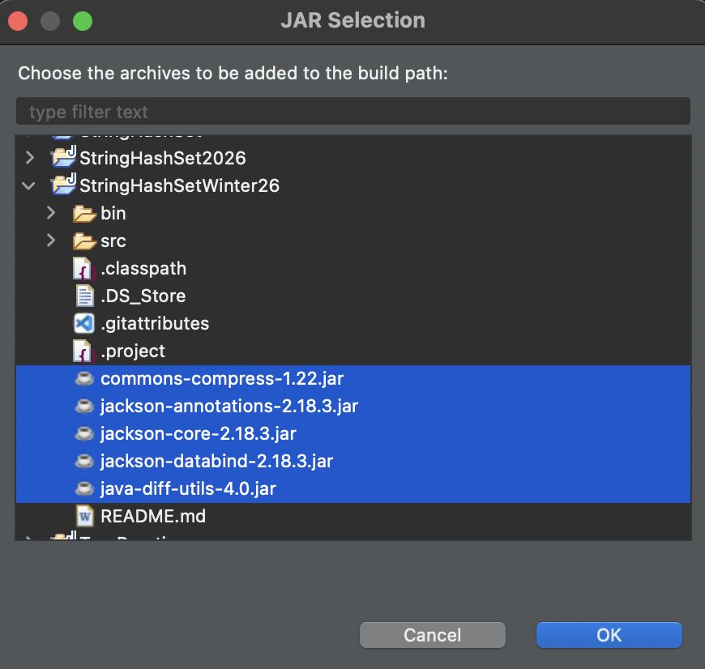
    - Will look something like this:
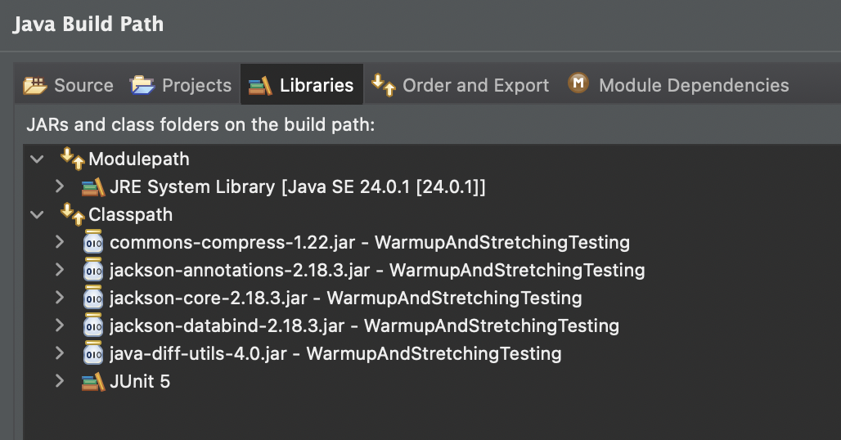
    - The Java version should be 15+

Adding the testSupport package
  - Create empty folder called testSupport under src
    - If there’s a pre-existing one (should be one for WarmupAndStretching, BinarySearchTree, and StringHashSet), delete it and recreate
  - Drag over files from here into the folder: testSupport
  - Also drag the META-INF folder from the provided src/ folder into your project’s src/ folder and select Copy files
  - Finally, add this annotation to each class containing an @Test annotation: 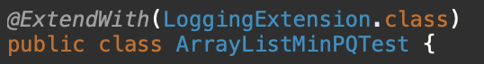
    - Remove annotations and unused imports for BeforeLoggingExtension and AfterLoggingExtension, all three have been consolidated into one class

